**New Product: Awesome Board Game**

**1.Goal:**

Design a product that allows people to borrow board games with other people and invite others to their home for board game sessions.

**2.Introduction:**

With rapid growth of logistics sector and digital consumers, many transactional activities are now being conducted over the internet. This has changed the traditional model of community sharing and product lending. The purpose of the proposed product is to promote borrowing and lending games to promote community sharing.

What is the product?Board Games Lending & Borrowing Platform.

Problem solved/ How will it help? Provides an easy way to lend or borrow board games and invite people for playing.

Who will use?End users -> Owners /Players/Borrowers.

* Lend board games Access product catalog
* Borrow games Access FAQ
* Invite people to play
* Return borrowed games
* Manage ‘My Account’.
* Access product catalog
* Access FAQ

**3. Research**

**3.1 Market Trends:**

The [board game](https://printninja.com/custom-board-games) industry has seen a major shift in recent years. Independent developers have shaken up the market, gaining traction for their games through crowdfunding and social media platforms. Now more than ever, the options for both game enthusiasts and designers alike are virtually limitless

**3.2 Market Board games statistics**

While the basic tools of today’s board games–cards, playing pieces, and the game board–may loosely resemble elements of classic games, many modern games are a far cry from Monopoly. Today’s gamers have changed, too. While the average household may have had a modest collection of games in decades past, you’re more likely to find dozens in the homes of today’s gamers. The majority of survey respondents, 57%, own between 1 and 25 board and card games, while 22% have between 26 and 50. Next up, 5.9% own between 76 and 100 games, while 4.2% of people own between 51 and 75 games. And, an impressive 10.9% own more than 100!

**4. Features**

**4.1 Workflows:**

Borrow game workflow:

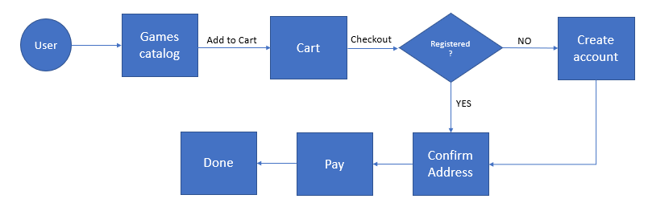

**4.2 Wireframes:**

4.2.1 Login

User logs in using Email ID and Password. It also contains ‘Create an Account’ option for new users.

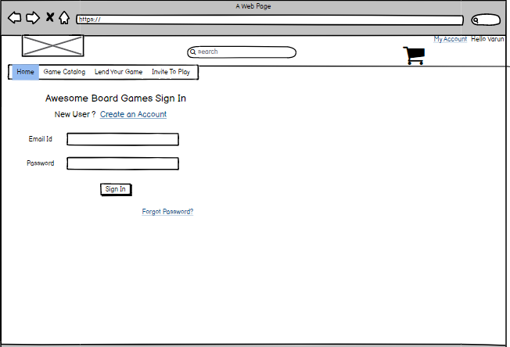

**4.2.2: Lend Game**

To lend a game, the user has to fill in the form with details of the product and submit for review.

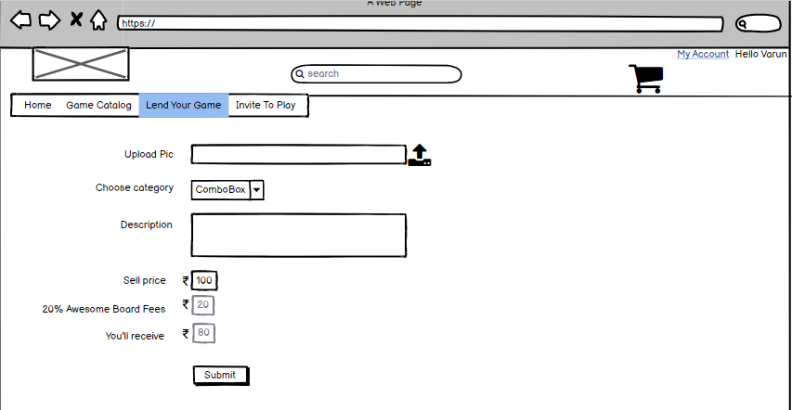

**4.2.3 Dashboard:**

Post Login dashboard contains navigation menus at the top with options to access catalogue, lending games, invite to play. It also contains a section highlight the popular games that are configured based on past user data.

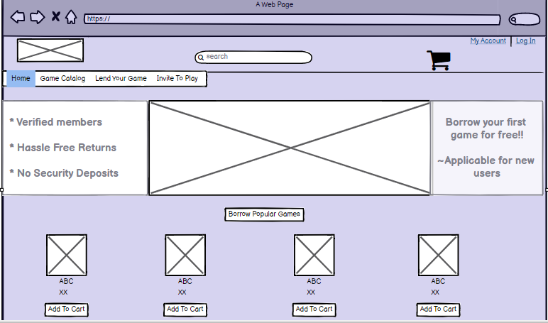

**4.2.4 Invite to Play**

The option of ‘Invite to Play’ allows users to invite the players filtered based on their postal code.

**5.1 ASSUMPTIONS:**

* Web portal to lend, borrow & invite people to play board games.
* Users will have to register to lend, borrow or invite people to play.
* Borrow period is valid for 2 weeks
* Valid for India region.
* Invite option lists users having same postal code.
* Platform charges 20% fees for putting board game for lending.

**6. Metrics**

**6.1 Monthly Recurring Revenue:**

Paying user is expected to grow by 60 % and ARPU (Average revenue per user) is estimated to increase by 10 % on quarterly basis.

|  |  |  |  |
| --- | --- | --- | --- |
| Quarter | Paying User | ARPU | Monthly revenue |
| Q1 | 500 | 120 | 60000 |
| Q2 | 800 | 132 | 105000 |
| Q3 | 1200 | 145 | 174000 |
| Q4 | 1500 | 160 | 240000 |

**6.2 Bounce rate**

Bounce rate refers to percentage users who visit only one page of a website or app and left. At start, bounce rate is expected to be around ~ 70% and plan to reach at 40% by subsequent quarter.

**6.3 Daily active user /Monthly active user ratio**

An average DAU/MAU ratio of 20 % is good to start with. Typically, board games are played frequently as compared to other products. Hence, it is expected to reach to 40% in subsequent quarter post launch.